Ideation Phase
Empathize & Discover

Date | 09 September 2026
Team ID | SWUID2026190415
Project Name | Medical Diagnosis Center by Service Portal (ServiceNow)
Maximum Marks | 4 Marks

Empathy Map Canvas:
An empathy map helps us understand the needs, thoughts, and challenges of users before developing a solution. For the Medical Diagnosis Center by Service Portal (ServiceNow) project, the main users are patients, lab technicians, receptionists, and administrators. This empathy map helps us understand their experience and design a user-friendly ServiceNow solution.
Example:
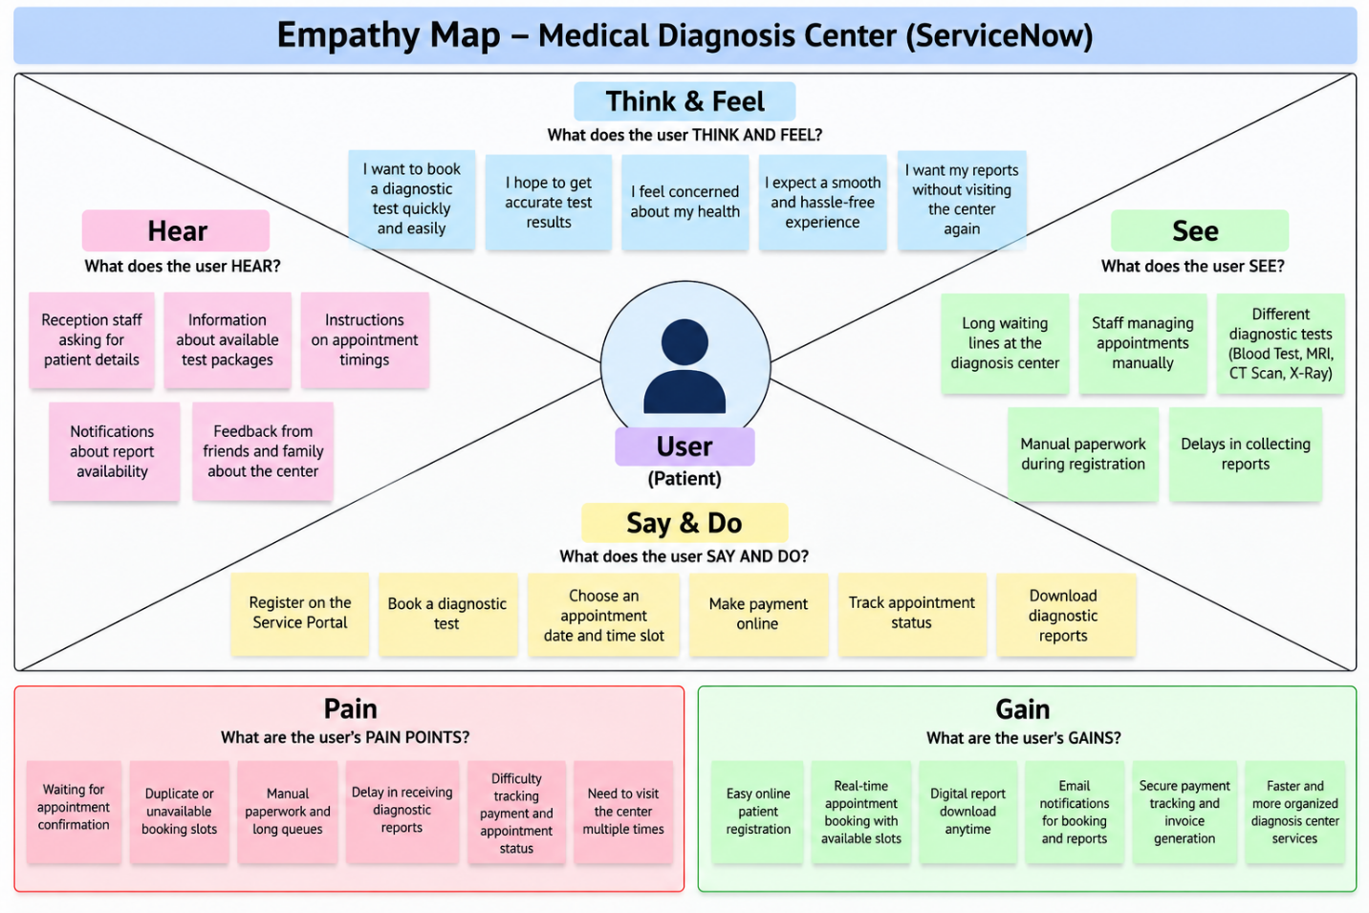

Reference: https://www.mural.co/templates/empathy-map-canvas

